Week 2 -Backend engineering & cloud integration

Project Architecture
The application consists of:
- React Frontend
- Auth Service (Node.js + Express)
- Task Service (Flask/Python)
- Database

Features Implemented
Auth Service
- User Authentication
- JWT Generation and Validation
- OAuth Integration
- Role-Based Access Control (RBAC)
- User Authorization

Implemented Features:
- Login APIs
- JWT Authentication
- OAuth-based Login
- Protected Routes
- Role Validation

Task Service
Responsibilities:
- Task Creation
- Task Retrieval
- Task Update
- Task Deletion

Implemented Features:
- Create Task API
- Get Tasks API
- Update Task API
- Delete Task API

Dockerization
Implemented:
- Dockerfile for Auth Service
- Dockerfile for Task Service

Purpose:
- Containerization
- Easy deployment
- Consistent development environment

Concepts Learned
Microservices
Definition:
Microservices are an architectural style where an application is divided into small independent services, each responsible for a specific business functionality.
Example:
- Auth Service
- Task Service
Benefits:
- Independent deployment
- Scalability
- Better maintainability

Ways of communication:
- Synchronous communication
-service sends request to another and wait for the response
Eg:REST API

- Asynchronous communication
-Service after sending the request it does not wait for the response
Eg:Kafka

REST API
Definition:
REST APIs enable communication between applications using HTTP methods such as GET, POST, PUT, and DELETE.
Examples:
GET /tasks
POST /tasks
PUT /tasks/:id
DELETE /tasks/:id

When to use REST API:
Services need simple request-response communication.
APIs are exposed to web/mobile clients.
Human-readable JSON is preferred.

When to use gRPC(order service-> inventory service->pricing service)
High performance communication
Microservices communicate frequently.
Low latency is important.
Large number of requests per second.

When to use GraphQL:(dashboard)
Frontend needs data from multiple services.
Different screens require different fields.

When to use Message Queue (Kafka/RabbitMQ) -Asynchronous Communication
Sender should not wait.
Event-driven architecture.
Reliability is important.

Pattern | When to Use
API Gateway | When clients (web/mobile) should not call every microservice directly. A single entry point handles routing, authentication, rate limiting.
Database per Service | When each microservice must be independent and own its data. Prevents tight coupling.
Saga Pattern | When a business transaction spans multiple services and distributed transactions are not feasible.
CQRS (Command Query Responsibility Segregation) | When read operations are much heavier than write operations.
Event-Driven Architecture | When services need to communicate asynchronously without waiting for responses.
Circuit Breaker | When a service dependency may fail and you want to prevent cascading failures.
Service Discovery | When service instances are dynamic (containers scale up/down).
Strangler Pattern | When migrating a monolithic application to microservices gradually.
Bulkhead Pattern | When one failing service should not consume all system resources.
Retry Pattern | When temporary failures (network glitches, timeout) can succeed on retry.
Sidecar Pattern | When common functionalities (logging, monitoring, security) should be separated from business logic.
Aggregator Pattern | When data from multiple microservices must be combined into one response.

JWT (JSON Web Token)
Definition:
JWT is a token-based authentication mechanism used to verify and identify users.
Workflow:
User Login-JWT Generated-sent to client-token will be sent with each requests-server validates token

Benefits:
- Stateless authentication
- Scalability
- Reduced server-side session storage

OAuth 2.0
Definition:
OAuth 2.0 is an authorization framework that allows users to grant access to applications without sharing passwords.
Example:
Login with Google
User
↓
Google Login
↓
Authorization Code
↓
Backend
↓
Access Token
↓
User Authenticated
Benefits:
- Secure authentication
- No password sharing
- Industry standard

Single Sign-On (SSO)
Definition:
SSO allows users to access multiple applications using a single login.

Example:
Google Account
↓
Task Manager Login

Benefits:
- Better user experience
- Reduced password management

RBAC (Role-Based Access Control)
Definition:
RBAC restricts system access based on user roles.
Roles:
- ADMIN
- USER
Example:
ADMIN:
- Create tasks
- Delete tasks
- Manage users

USER:
- Create tasks
- Update own tasks
Benefits:
- Improved security
- Fine-grained access control

Rate Limiting | Rate Throttling
Defines the maximum number of requests allowed in a time window. | Actively slows down or rejects requests when the limit is exceeded.

Middleware
Definition:
Middleware is a function that executes between receiving a request and sending a response.
Examples:
- Authentication Middleware
- Logging Middleware
- Validation Middleware
Workflow:
Request
↓
Middleware
↓
Controller
↓
Response

Docker
Definition:
Docker is a containerization platform used to package applications and dependencies together.
Benefits:
- Portability
- Consistent environments
- Simplified deployment

AWS-
RDS-Database
ECR-stores the images
ECS-run the container
->After building the application->build the docker image->push to ECR using cmd:
docker tag <img_name> <repo_url

docker push <ecr-repo-url>
->In ECS,create task definition-It is like a blueprint
It tells ECS:
- Which image to use
- CPU needed
- Memory needed
- Port number
->create ECS service
->launches the task
->It uses RDS database

Development Workflow
Step 1:
Created Auth Service using Node.js and Express.
Step 2:
Implemented JWT Authentication.
Step 3:
Implemented OAuth-based Login.
Step 4:
Implemented RBAC Authorization.
Step 5:
Created Task Service using Flask.
Step 6:
Implemented CRUD Operations.
Step 7:
Established communication between Auth Service and Task Service.
Step 8:
Created Dockerfiles.
Step 9:
Built images

Schema diagram:
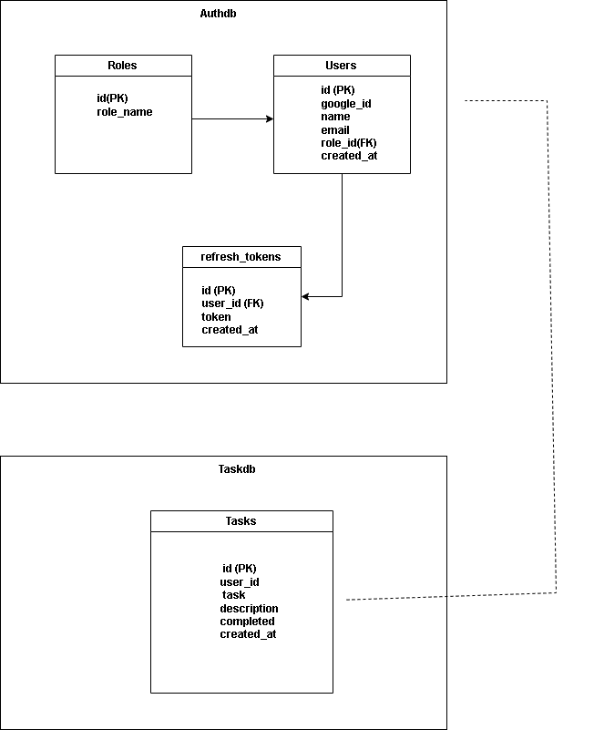

Architecture diagram:
Task manager application
